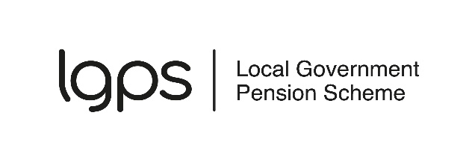
Previous pension benefits declaration
The Government limits the amount of tax-free cash you can take from a registered pension scheme. If you wish to take a lump sum when you take your pension, we need to know about any pension benefits you have taken previously to check you don’t exceed the lump sum limits. Although most members will not be affected by the limits, we must carry out the checks for everyone.
We do not need to know about your state pension or any dependents pensions you are receiving.

Personal information
Full name
National Insurance number

Taking a lump sum
Q1. Are you taking a tax-free lump sum?
Yes |  | If you are taking a tax-free lump sum, go to Q2
No |  | If you are not taking a tax-free lump sum, go to section 7
Q2. Do you hold a transitional tax-free amount certificate (TTFAC)?
Yes |  | Attach a copy and tell us about any lump sums you have received since it was issued in section 3
No |  | If you don’t hold a TTFAC, go to Q3
Q3. Have you taken payment of any pension benefits before?
Yes |  | Tell us about all the pension benefits you have taken in section 3
No |  | If you have not taken payment of any pension benefits before, go to section 5

Previous pension benefits
Use this section to tell us about the pension benefits you have taken previously. The information we need depends on when your pension benefits were first paid to you. Only complete the sections that are relevant to you.

Lump sums paid from 6 April 2024
For pension benefits paid from 6 April 2024, we only need to know about any tax-free lump sums you have been paid. In this section, tell us about:
- pension commencement lump sums (PCLS) – these are tax-free lump sums you take when you start taking a pension
- uncrystallised funds pension lump sums (UFPLS) – this is a type of lump sum paid from a defined contribution scheme. Only tell us about the tax-free part of the lump sum in this section.
Pension provider | Date paid | Amount of tax-free lump sum paid

Pensions and lump sums paid between 6 April 2006 and 5 April 2024
For these pension benefits, we need to know the percentage of lifetime allowance (LTA) used. The pension provider that pays the benefits to you will have notified you of this. If you do not have this information, provide the amount of yearly pension at the date it was first paid and any tax-free lump sum paid. If you took an UFPLS, tell us about this in the last column - include the whole UFPLS amount ie the taxable and tax-free amounts.
Pension provider | Date first paid | LTA % | Yearly pension | Tax-free lump sum | Total UFPLS

Pensions first paid before 6 April 2006
If you took payment of pension benefits before 6 April 2006, we need to know the amount of yearly pension you are currently being paid.
Pension provider | Date first paid | Current amount of yearly pension

Other lump sums and transfers
Have you ever been paid a Serious ill health lump sum? |  | YES / NO
If yes, provide the amount and date paid | Date: | Amount:
Have you ever been paid a stand-alone lump sum? |  | YES / NO
If yes, provide the amount and date paid | Date: | Amount:
Did you transfer any UK pension benefits to an overseas pension scheme before 6 April 2024? |  | YES / NO
If yes, provide the amount and date paid | Date: | Amount:

Tax-free lump sum being paid on the same day
Are you taking another tax-free lump sum on the same day as your LGPS tax-free lump sum is payable? | YES / NO

Lifetime allowance (LTA) protections and enhancements
If you have any LTA protections or enhancements, tell us about them below:
Type of LTA protection / enhancement | HMRC reference number

Declaration
I confirm the information I have provided in this form is, to the best of my knowledge, true and complete. I am not taking a tax-free lump with the intention of significantly increasing pension contributions to another pension scheme. I understand I will be wholly and personally liable for any tax charges and penalties imposed by HMRC if the information I have provided is found to be incorrect.
Signed: | Date:
Return this form to: XXXXXXXXXXXX

