


A V Cs and Pensions Dashboards guide for L G P S administering authorities

Index
1. Introduction 2
2. Your legal obligations and Memorandum of Understanding 4
3. Reconciling main scheme records with A V C records 5
4. Deciding how to send A V C view data to the ecosystem 6
5. Pros and Cons – multiple source v single source 8
6. A V Cs dashboards risk register 24
7. Due diligence questions to ask your A V C provider(s) 25
8. Disclaimer 25
9. Copyright 25
Appendix 1 – template reconciliation report 26
Appendix 2 – A V Cs dashboards risk register 29
Appendix 3 – definition of normal pension age 31
Appendix 4 – definition of normal benefit age 36
Appendix 5 – multiple & single source due diligence questions 37

Introduction

Using this guide
This guide must be read in conjunction the L G P S Pensions Dashboard connection guide for administering authorities. Definitions for all terms used in this guide can be found in the connection guide. This can be found on the:
- Administrator guides and documents page of www.lgpsregs.org
- Administrator guides and documents page of www.scotlgpsregs.org

National L G P S Technical A V C sub-group
This guide was created by the Local Government Association (L G A) with help from the National L G P S Technical A V C sub-group. Its aim was to establish common approaches on the preparation and provision of A V C view data to the pensions dashboards ecosystem (hereafter known as ‘dashboards’ or ‘ecosystem’).
Thanks go to representatives from the Prudential, Leicestershire Pension Fund, Northern Ireland Local Government Superannuation Committee, Tyne & Wear Pension Fund, West Yorkshire Pension Fund, Heywood Pension Technologies, Civica and the Pension Administration Standards Association.

Why is this guide needed?
The Pensions Dashboards Regulations 2022 (as amended) make provision for pensions dashboards services. These are intended to enable individuals and other authorised persons, to request and view information relating to their pension entitlements electronically.
In summary, you will need to reach agreements with your A V C provider(s) about:
- how you will reconcile your main scheme benefits with your A V C data and how you intend maintain that reconciliation
- how your A V C view data will be sent to the ecosystem – multiple source or single source
- how you will determine your A V C matching criteria and illustration dates
- the circumstances by when estimated retirement income might be provided.
You will need to be able to accommodate a variety of approaches from different A V C providers. One size will not fit all.

How can this guide help you?
We believe even though a variety of approaches will be adopted in sending view data to the ecosystem, we should be able to achieve consistency within each form of approach. This guide helps you do that and expands on the A V C actions set out in the L G P S Pensions Dashboard connections guide.

Orphan A V Cs and relevant members
It is our understanding that there are two types of orphan AVCs:
- True Orphan AVCs - any AVCs that remain with an administering authority where a transfer payment of the connected main scheme benefits has been made under Regulation 96(1) of the LGPS Regulations 2013 (or equivalent predecessor regulations), which did not include the member's AVCs.
- Internal Orphan AVCs - any AVCs that remain with an administering authority where either the member’s connected main scheme benefits have been:
- brought into payment, but their connected AVCs remain unpaid, or
- aggregated with a different administering authority in the Scheme, but the member chooses not to aggregate their connected AVCs to that administering authority.

‘Connected’ means the main scheme benefits built up in the employment where the active member made an election to pay AVCs or contribute to SCAVCs.

Relevant members
Only members who are relevant members for dashboard purposes will have their view data displayed on the MHPD. We understand an orphan AVC is a relevant member where the connected main scheme benefits have:
- been transferred out of the LGPS – true orphan AVC
- not been brought into payment – internal orphan AVC.
An internal orphan AVC is not a relevant member where the connected main scheme benefits have been brought into payment.

Your legal obligations and AVCs Memorandum of Understanding
Regulation 17 of the L G P S Regulations 2013 (and equivalent predecessor regulations) requires the administering authority (‘you’) to establish an A V C scheme with a body approved for such purposes under the Finance Act 2004.
When you appoint an A V C provider to administrate your day to day A V C scheme, you are delegating responsibility to that provider to make sure the scheme is run in accordance with the L G P S Regulations and over-riding legislation. The provider must be suitably regulated in accordance with the Finance Act 2004 to provide regulated information to your members.
However you decide to send your A V C view data to the ecosystem, you remain responsible for the accuracy and provision of A V C view data. You should discuss with your A V C provider(s) how best to send your A V C view data to the ecosystem. To support these discussions and help ensure compliance, we have developed a template Memorandum of Understanding (MOU). The MOU is designed to work with both the multiple source approach and single source approach.
While the MOU is not legally binding, it serves as a practical framework for both parties to clarify how they will meet dashboard and data protection requirements, whether using a single or multiple-source approach. You may later decide to formalise these arrangements through legally binding contracts, for which you should seek your own legal advice. This template MOU and accompanying notes were developed with reference to the law in England and Wales. While the Pensions Dashboards Regulations 2022 and Data Protection laws apply across the UK, Scottish Administering Authorities may wish to seek their own legal advice to confirm applicability and make any necessary adjustments to references within the documents.
You can find the template MOU and explanatory notes on the following web pages, use the subject filter to view all Pensions Dashboards resources:
- Administrator guides and documents page of www.lgpsregs.org
- Administrator guides and documents page of www.scotlgpsregs.org

Reconciling main scheme records with A V C records

Step one - reconciliation
The first step in the A V Cs and dashboards process is to make sure your main scheme A V C records match your A V C provider(s) records. This is so when a user accesses a dashboard, the correct A V C view data is shown alongside the corresponding main scheme record. Unless the record is an orphan A V C, in which case we expect the A V C view data will be shown in isolation.
To reconcile your main scheme A V C data with that of your A V C provider(s) you will need to contact your A V C provider(s) to obtain your A V C data. Thereafter, you will need to work through the data and reconcile any differences.

Step two – maintain reconciliation
The second step in the process is to maintain your reconciliation.
You will need to devise a process to keep your main scheme A V C records and your A V C provider(s) records aligned. This is to make sure each time a user accesses a dashboard the correct A V C view data is shown alongside the corresponding main scheme record. Unless the record is an orphan A V C, in which case we expect the A V C view data will be shown in isolation.

Template reconciliation report
To help you, we have created a reconciliation template. This contains the fields we suggest your A V C provider(s) populate.
The template was designed with help from Prudential. Prudential confirm this template will be automated so it can be run as frequently as necessary.
Some of the fields may be local to Prudential, so you will need to agree the fields within the template with your A V C provider(s) before requesting its completion.
The template report can be found in appendix 1.

Deciding how to send A V C view data to the ecosystem
Alongside the reconciliation of your main scheme A V C records with those of your A V C provider(s), and creating a process to main reconciliation, you also need to consider how your A V C view data will be sent to the ecosystem.
Before we look at the pros and cons of the various approaches – set out in section five, you should read this section. In this section we consider the following within the context of deciding how to send your A V C view data to the ecosystem:
- your legal obligations
- the data standards
- ready for change
- consider what is already in place.

Your legal obligation
As we have already set out in section two, the legal obligation to provide A V C view data to the ecosystem falls on you, though there will be two or more parties carrying out your duties – you and your A V C provider(s). You should be fully aware of how your dashboard duties will be carried out and take an active part in all the decision making.

Data standards
More information can be found in the PDP data standards.
To support the wide variety of pension arrangements in the U K, where there are two or more parties involved, the data standards allow for three options to send view data to the ecosystem:

Multiple source linked

A V C view data sent direct to the ecosystem by your A V C provider(s)
Following a successful find request, your A V C provider(s) will send your A V C view data directly to the ecosystem. There will be a unique code (called a Globally Unique ID - GUID) to link the member’s main scheme benefits with their A V C benefits.

Multiple source not linked

A V C view data sent direct to the ecosystem by your A V C provider(s)
Potentially there is another approach where your A V C view data is sent direct to the ecosystem by your A V C provider(s). This is where the unique code (called a Globally Unique ID - GUID) to link the member’s main scheme benefits with their A V C benefits is not used.
We do not recommend this approach because we do not believe this will benefit your members experience of using dashboards.

Single source

A V C view data periodically sent to you by your A V C provider(s), for you to send to the ecosystem
Your A V C provider(s) will send your A V C view data to you periodically. Your A V C view data will need to be stored in a digitally accessible mode. You will need to agree the frequency of the periodic data provision with your A V C provider(s).
Following a successful find request, you will send your A V C view data directly to the ecosystem.

Consider what is already in place
Dashboards do not ask you or your A V C provider(s) to do anything you do not already have to do if the member asks you for information directly. So, consider what is already in place.
Ask yourself the following:
- how do our current ABS show main scheme benefits alongside A V Cs?
- how do we prepare a retirement estimate where the member holds A V Cs?
- if the member has a query concerning their A V Cs who do they speak to?
- is there anything already in place we can repurpose for sharing dashboard information?
The data standards are designed to reflect the most common ways in which main scheme benefits and A V C benefits are communicated to members - either sent separately or combined by you in some way.
Therefore, we should consider the relative pros and cons of the three options through three lenses:
- Getting ready and onboarding.
- Live running
- Supporting other pensions activities.

Pros and Cons – multiple source v single source
Please read section four to understand the context of this section.
It is important you and your A V C provider(s) work together to make sure your A V C data is reconciled with your main scheme data and is accurate and accessible – regardless of the approach chosen. This activity is not considered a pro or a con in this analysis - it is simply a necessity.

Multiple source – linked and not linked
You send your main scheme view data to the ecosystem, and your A V C provider(s) send your A V C view data to the ecosystem – the multiple source approach.
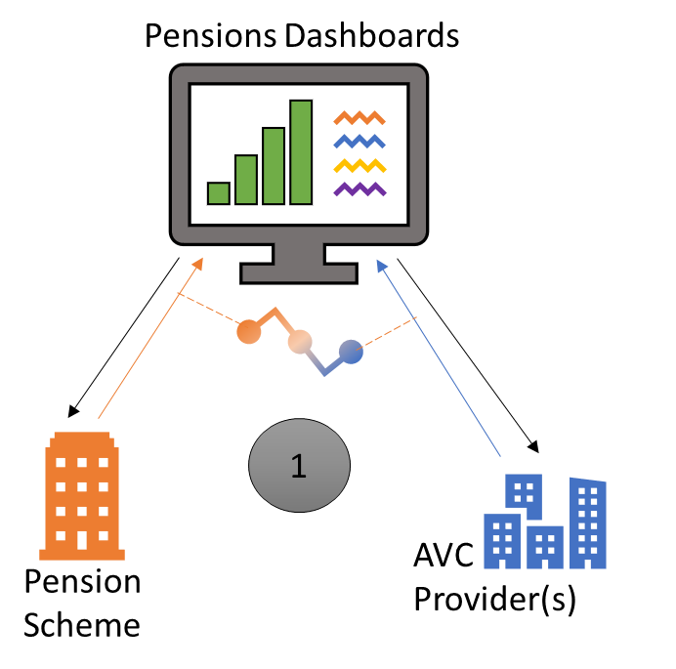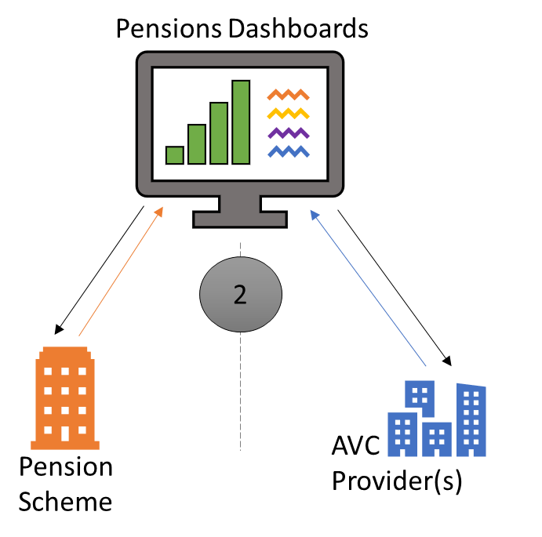

Multiple source - key components:
Both you and your A V C provider(s) respond separately to dashboard requests.
Matching, data submission and reporting carried out by both you and your A V C provider(s) simultaneously.
In option 1 – multiple source linked, you will generate a Globally Unique ID (GUID) that is local to you and send that to all your A V C provider(s) to use. Once live, this GUID value is sent in the value data that both you and your A V C provider(s) send to the ecosystem. This enables the dashboard’s display rules to pin the two or more data entries together onscreen.
In option 2 – multiple source not linked, if no GUID is used, the order in which the pension benefits are displayed will be solely down to the display logic used by the chosen dashboard. The member’s main scheme benefits and A V C benefits might not be displayed together. We do not recommend using this option.

Multiple source – pros and cons

Getting ready and onboarding

Multiple source - getting ready and onboarding | Pros | Cons
Data storage and formatting | You do not need to create a new interface between you and your A V C provider(s).  You do not need to add any new storage to your pensions administration system. | The A V C information will appear as a separate pension benefit to the main scheme benefits scheme on the member’s chosen dashboard.  If a GUID is:  - used, it will be displayed alongside the main scheme benefits  - not used, you have no control over where the A V C view data is displayed.
Matching rule readiness |  | You will have to co-ordinate the data quality, data readiness and matching rule logic across all elements of both the main scheme view data and A V C view data.  You will need to be confident the matching outcomes are the same. To achieve this the matching data held by both you and your A V C provider(s) and the application of the matching rules, will ideally need to be the same. As you are likely to set different matching rules based on the confidence in your data availability and accuracy, you will need to check if your AVC provider can adopt bespoke matching criteria for your authority.
Designing processes |  | To allow for the fact a member might contact you rather than your A V C provider(s), and possibly vice versa, both you and your A V C provider(s) will need to create new processes to allow for resolving possible matches and resolving queries. This is because each administrator will only have carried out one half of the data submission.
Onboarding |  | You will need to know how your A V C provider(s) plan to connect and meet their duties under the legislation.  Your A V C provider(s) will need to demonstrate to you their connection is compliant and will remain compliant.  You must be in control of the onboarding process and co-ordinate a live date with your A V C provider(s). Your A V C provider(s) cannot onboard your A V C view data before your ‘connect by’ date.  You will also need assurance from your A V C provider(s) they have controls in place to prevent your A V C view data being onboarded early.

Live running
Multiple source - live running | Pros | Cons
Data storage | You will not need to factor in new processes for missing calculation values as this will be part of your A V C provider(s) messaging - although you remain legally responsible. | You will need to make sure your A V C provider(s) have processes in place to send stored A V C value data calculated within the prescribed date, to the ecosystem. Or a process in place to calculate the value and send this to the ecosystem within the 10 days set out in legislation.
Matching rule maintenance |  | You will have to monitor your main scheme experience alongside that of your A V C provider(s), to make sure ongoing matching rule is effective.  Any updates will need coordinating and testing with all your A V C provider(s) to go live concurrently.
Resolving pensions that need action results |  | You may not know your A V C provider(s) has returned a pensions that need action result unless the member contacts them.  You will need processes in place to co-ordinate resolving matches with your A V C provider(s) if the member has not contacted the A V C provider(s) directly. Also, vice versa if the A V C matching was a confirmed pension and your result is a pension that needs action.
Handling queries | Where your members contact A V C provider(s) directly with their queries, the dashboard can display your A V C provider(s) contact details against your A V C view data. | You will not know what values have been sent to the ecosystem and you will be unable to respond to queries without either contacting your A V C provider(s) or having a separate way to see what your A V C provider(s) have sent.
Providing evidence to the regulator |  | You will have to be able to combine your main scheme information with your A V C provider(s) information to respond to any regulator’s queries or requests for evidence.  You will need to make sure your A V C provider(s) are able to provide this information for both you and individual members as necessary.

Supporting other pension activities
Multiple source - supporting other pension activities | Pros | Cons
Making other use of A V C data |  | Because you will not be holding dashboard compliant A V C view data, there are pros to benefit from holding that additional information eg you could automatically include the A V C value when manually providing estimates to members or automated estimates by way of your online provision.
Sharing information |  | Without new interfacing between you and your A V C provider(s), other processes will need to be in place. This is so any changes required by both parties are automatically provided if the member only updates one provider eg if a deferred member updates their surname or address with their A V C provider but forgets to update you.

Single source
You take responsibility for sending A V C view data to the ecosystem – single source approach.
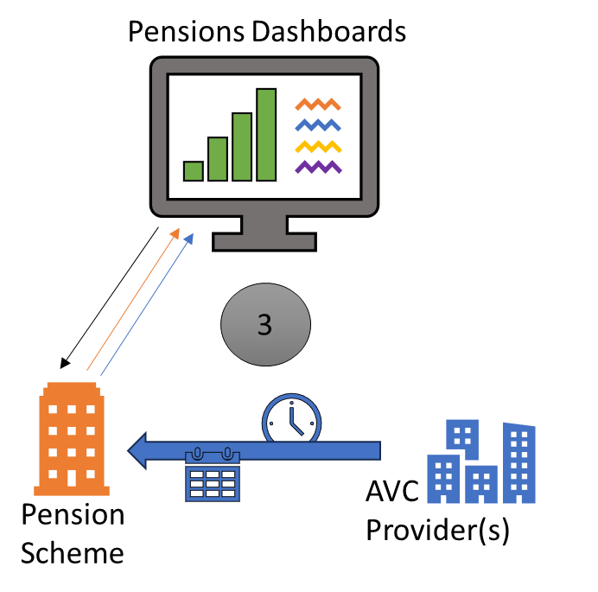

Single source - key components
In option 3, the A V C provider(s) sends your A V C view data in bulk to you on a periodic basis or on demand.
You store the information ready for responding to dashboard requests when a member uses one.
Matching, data submission, reporting - all carried out by you.

Single source - Pros and Cons

Getting ready and onboarding
Single source - getting ready and onboarding | Pros | Cons
Data storage & formatting | You can choose how you use the formatting to control how the information is displayed eg either send two complete sets of information, or one set of information with the estimated retirement income and accrued values repeating. | Unless you already receive and store all elements of A V C view data, new data interfaces and new storage will need to be added to the record keeping areas in the pensions administration system and in the A V C provider(s) systems. A V C providers have confirmed they might need to change their record keeping to support a new data interface.  This might result in additional charges from both your pensions administration software provider and your A V C provider(s).
Matching rule readiness | You will be solely responsible for matching against your own data and you will not need to check and verify your A V C provider(s) rules. | You will need to be able to align and apply the A V C view data to the correct member and if more than one member record, correct member employment record, in your pensions administration system.  Though this can done offline, away from live dashboard interactions to make sure all the A V C view data is attributed correctly.
Designing processes | If you store and send all elements of the view data, it can be the single point of contact for member queries arising after a dashboard visit. | You will need to design new processes to make sure queries are resolved by the AVC provider(s) where members would normally contact the A V C provider(s) directly.
Onboarding | You are in complete control of the onboarding process and will not have to co-ordinate a live date with your A V C provider(s).

Live running
Single source - live running | Pros | Cons
Data storage | You will be able to monitor your ongoing dashboard data readiness in one place. | You will need to make sure any stored A V C data is calculated within the prescribed date. Otherwise, you will need a process in place to make sure your A V C provider(s) can send updated values to you, so you can send this data to the ecosystem within the 10 days set out in legislation.
Matching rule maintenance | You can use your own experience to monitor your matching rule effectiveness and update the rule in one place, without coordinating and testing with your A V C provider(s).
Resolving pensions that need action results | Where a find request results in a pension that needs action, you will only need to look at your own data. You are also the sole point of contact and so members will always know who and where to contact.
Handling member queries | You will always know what values have been sent to the ecosystem and will be able to respond to queries. | If members are used to contacting your A V C provider(s) directly, the A V C provider(s) will need to liaise more with you to resolve queries.  Though depending on the method you choose to submit data to the ecosystem, it might be possible to hold a second set of contact details for your A V C provider.
Providing evidence to the regulator | You will hold all view data, so you will be the single point of contact for regulator queries.

Supporting other pension activities
Single source - supporting other pension activities | Pros | Cons
Making use of A V C data | You will hold dashboard compliant A V C data. You can choose to use that information for other activities - such as retirement illustrations.
Online portal | You can provide a single view of all a member’s benefits by way of an online portal. | If your A V C provider(s) already provides online portals, there might be an issue if the data you display on an online portal is around a year older than that displayed on your provider(s) real time portal. This could cause member queries if not notified sufficiently.
Sharing information | If new interfacing is put in place, it could be the conduit to having one single way in which A V C provider(s) send information to you - for example, settling final retirement figures.

Other considerations

How data may be submitted to the ecosystem
In the single source pros and cons section of providing view data, the ability to affect how the data was displayed is listed as a ‘pro’.
Setting aside the source of approach – ie multiple versus single, there are two ways you can submit main scheme view data and A V C view data to the ecosystem. You should discuss the methods with your I S P.
The data elements you return when asked for view data are:
Data elements | Description
2.0xx pension arrangement data | information about you
2.1xx administrator data | your contact details
2.2xx employment data | information about the member’s employer and pensionable service (optional)
2.3xx estimated retirement data | the estimated pension values at NPA relating to the member’s benefits
2.4xx accrued benefit data | the accrued pension values relating to the member’s benefits
2.5xx value data illustration date | the date at which the values in 2.3xx and 2.4xx were calculated
2.6xx signpost data | where to find further information, such as annual reports and cost & charges
Elements 2.3, 2.4 and 2.5 can be sent multiple times within one submission.
The data standards support two methods of data submission. Represented visually, these are shown in the following two diagrams where the orange icons represent the scheme benefits, and the blue icons are the A V C benefits:

Two-submission method
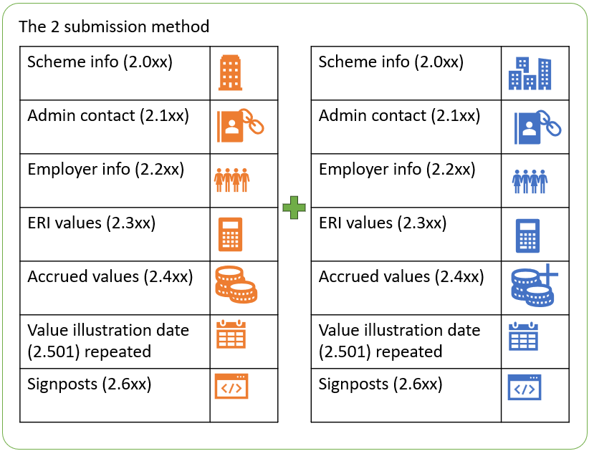

All-in-One submission method
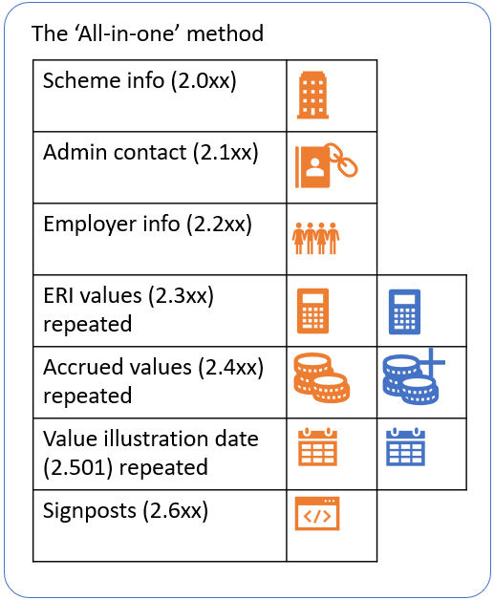

Two-submission method versus All-in-One submission method
If you decide to use the multiple source approach, either linked or not linked, your data will automatically be shown separately as the two-submission method.
If you wish your data to be shown as repeating elements within one submission, as the all-in-one method, you will need to use the single source approach and have all your A V C view data held alongside the main scheme data.
If you decide to use the single source approach and hold your A V C data alongside your main scheme data, you could still choose to use the two-submission method if you think that would be clearer to the member. The final decision may require some user testing to gain some consistency.

Multiple scheme benefits and multiple A V Cs
The data standards, specifically the use of the multiple source approach with a GUID, do not resolve the issue where your members have multiple benefits with multiple A V C policies connected to separate employments.
When using the multiple source approach, if you and your A V C provider(s) use the same GUID for all submissions, there is a risk your A V C view data will not correspond with the correct main scheme benefits. This issue is not specific to the L G P S and not specific to A V Cs. This is an issue for all schemes with multiple sections and multiple administrators, and we expect to be addressed by P D P.
The only way you can currently be sure the correct A V C policy is linked to the connected main scheme employment record, is to adopt the single source approach. This is because you will be responsible for allocating the A V C data to the correct main scheme record and in turn, sending all the data to the ecosystem as a single return.

A V Cs dashboards risk register
To help you identify the main risks when undertaking A V Cs and dashboards we have created a template dashboards risk register.
We have also scored the risks, but these are merely suggestions as we appreciate you will have different views on risks and mitigations.
Our suggested scores are based on likelihood (L) and impact (1). With (1) been low and (5) high. The total risk is (L) multiplied by (I).
Our template risk register is set out in appendix 2.

Due diligence questions to ask your A V C provider(s)
Once you have decided your approach to sending A V C view data to the ecosystem you need to liaise with your A V C provider(s).
Findings indicate there are 10 A V C providers who L G P S administering authorities have entered into agreements to establish A V C arrangements. These are:
- Aegon
- Aviva
- Clerical Medical
- Legal & General
- Phoenix Life
- Prudential
- Scottish Widows
- Standard Life
- Utmost Life & Pensions
- Zurich.
We have set out a series of due diligence questions you should address with each of your A V C provider(s), your pensions administration software providers and your integrated service provider (I S P), depending on your approach ie multiple source or single source. These are set out in appendix 5.

Disclaimer
The information contained in this summary guide has been prepared by the L G P C Secretariat, a part of the L G A. It represents our views and should not be treated as a complete and authoritative statement of the law. Readers may wish, or will need, to take their own legal advice on the interpretation of any piece of legislation. No responsibility whatsoever will be assumed by either party for any direct or consequential loss, financial or otherwise, damage or inconvenience, or any other obligation or liability incurred by readers relying on information contained in this Guide.

Copyright
Copyright remains with the L G A. This Guide may be reproduced without the prior permission of the L G A provided it is not used for commercial gain, the source is acknowledged and, if regulations are reproduced, the Crown Copyright Policy Guidance issued by H M S O is adhered to.

Appendix 1 – template reconciliation report
Heading | Description | Comments
NINO | Customer national insurance number if held
Policy number | Unique identified for customer policy and is used on customer communications
Title | Salutation used by customer in communications
Surname | Customer surname
Forename | Customer forename
Initial | Initial for customer
D O B | Customer date of birth
N P A | Member’s normal pension age (N P A) / normal benefit age (N B A) as defined in the LGPS Regulations under which the member either left active membership, was awarded a pension credit or is active. | See appendix 3 for the definition of a scheme members N P A, and appendix 4 for the definition of a pension credit members N B A
Intended retirement date | The date at which the member wishes to retire | This may be the same as N P A / N B A
Policy start date | Date at which the policy was added to the scheme
Employer code | Alpha numeric between four to five digit code A V C provider uses to identify individual employer within the same scheme
Employer name | Name of employer - supplied when policy set up associated with the employer code
Scheme number | Unique identifier used for identifying different schemes
Scheme name | Linked to employer name and scheme number to identify different schemes
A V C policy status at policy number level | Contribution holiday – in force
A V C policy status at policy number level | Active – in force
A V C policy status at policy number level | Out of force
A V C policy status at policy number level | Paid up - deferred
Last contribution date paid | Last date premium paid against the policy | Must be last premium paid not last transaction as this will pick up AMC
Reconciliation Contribution Status at policy | Derived by Last Contribution Date Paid, if that date is within the last 12 months show as Active, if it is more than 12 months should show as deferred
Owner1 Address Line 1 | Address Line 1 | If held, may be blank for some customers
Owner1 Address Line 2 | Address Line 2 | If held, may be blank for some customers
Owner1 Address Line 3 | Address Line 3 | If held, may be blank for some customers
Owner1 Address Line 4 | Address Line 4 | If held, may be blank for some customers
Owner1 Address Line 5 | Address Line 5 | If held, may be blank for some customers
Owner1 Postcode | Post code | If held, may be blank for some customers

Appendix 2 – A V Cs dashboards risk register
Source | Risk | (L) | (I) | Total score
Multiple & Single | - Failure of an A V C provider to liaise with you on dashboards, thereby not enabling compliance with the legislation | 2 | 5 | 10
Multiple & Single | - Failure to reconcile your A V C data | 2 | 4 | 8
Single | - Failure of the A V C provider to send you the A V C view data securely and in an agreed timely manner | 2 | 5 | 10
Single | - Failure of the A V C system provider to build a secure link | 1 | 5 | 5
Single | - Failure to make the pensions administrator system changes to hold the A V C view data | 2 | 5 | 10
Multiple & Single | - Monetary funds and / resource are not available to administer all dashboard requirements including but not limited to:  - reconciliation process  - dealing with member enquiries  - liaising with employers / A V C provider to resolve queries  - procure / purchase an integrated service provider  - purchase an interface from A V C provider to you to maintain reconciliation | 2 | 5 | 10
Multiple & Single | - Insufficient resource at the A V C provider to administer all dashboard requirements including but not limited to:  - deal with your initial and ongoing reconciliation processes  - resolving queries  - ongoing data submission | 2 | 5 | 10

Appendix 3 – definition of normal pension age
Over the years normal pension age (N P A) has had various names. It was previously called normal retirement age and before that normal retirement date. For ease, all reference in this guide will be made to N P A. You should not confuse N P A with critical retirement age relating to the 85-year rule protections or the impact of the underpin where applicable.

L G P S England and Wales

2014 Scheme
Applies to members who leave active membership of the L G P S on or after 1 April 2014
- N P A = SPa or if later age 65
Members can defer payment to immediately before age 75. Where payment is made after NPA late retirement increases apply. Dashboards value data should include late retirement increases where appropriate.

2008 Scheme
Applies to members who left active membership of the L G P S on or after 1 April 2008 and before 1 April 2014
- N P A = age 65
The 2008 Scheme contains a protected N P A of age 60 for certain groups of members who have transferred by statute from elsewhere within the public service (e g meat hygiene, Learning and Skills Council, N H S). More information is in appendix B of the Discretions policy found in the Administrator guides and documents page of www.l g p s regs.org.
Members can defer payment to immediately before age 75. Where payment is made after age 65 late retirement increases apply. Dashboards value data should include late retirement increases where appropriate.

1998 Scheme
Applies to members who left active membership of the L G P S on or after 1 April 1998 and before 1 April 2008
- N P A = age 65, or
- a member who joined the scheme before 1 April 1998 and left active membership of the scheme before 1 October 2006, N P A = the earlier of:
- age 60 if by that age, the member would have built up 25 or more years membership of the scheme if they had remained active until then, or
- the date the member would have built up 25 years membership, if that date falls after age 60 and before age 65, or
- age 65 if by that age, the member would not have built up 25 years membership of the scheme if they had remained active until then.
The 1998 Scheme contains a protected N P A of age 60 for certain groups of members who have transferred by statute from elsewhere within the public service (e g meat hygiene, civil service). More information is in appendix B of the Discretions policy found in the Administrator guides and documents page of www.l g p s regs.org.
Members can defer payment to immediately before age 75. Where payment is made after age 65 late retirement increases apply. Dashboards value data should include late retirement increases where appropriate.

1995 Scheme
Applies to members who left active membership of the L G P S before 1 April 1998
- N P A = the earlier of:
- age 60 if by that age, the member would have built up 25 or more years membership of the scheme if they had remained active until then, or
- the date the member would have built up 25 years membership, if that date falls after age 60 and before age 65, or
- age 65 if by that age, the member would not have built up 25 years membership of the scheme if they had remained active until then.
There is no option to defer payment beyond N P A in the 1995 Scheme, dashboard value data must be quoted at N P A so as not to overquote entitlement.

L G P S Scotland

2015 Scheme
Applies to members who leave active membership of the L G P S on or after 1 April 2015
- N P A = SPa or if later age 65
Members can defer payment to immediately before age 75. Where payment is made after N P A late retirement increases apply. Dashboards value data should include late retirement increases where appropriate.

2009 Scheme
Applies to members who left active membership of the L G P S on or after 1 April 2009 and before 1 April 2015
- NPA = age 65
The 2009 Scheme contains a protected N P A of age 60 for certain groups of members who have transferred by statute from elsewhere within the public service (e g, Scottish Administration’s Learning Connections Division, Care Commission, the Social Work Inspection Agency, Her Majesty’s Inspectorate of Education, Scottish Legal Complaints Commission and persons formerly entitled to a pension under the SDS Scheme). More information is in appendix B of the Discretions policy found in the Administrator guides and documents page of www.scotlgpsregs.org.
Members can defer payment to immediately before age 75. Where payment is made after 65 late retirement increases apply. Dashboards value data should include late retirement increases where appropriate.

1998 Scheme
Applies to members who left active membership of the L G P S on or after 1 April 1998 and before 1 April 2009.
- N P A = age 65, or
- a member who joined the scheme before 1 April 1998 and left active membership of the scheme before 1 December 2006, N P A = the earlier of:
- age 60 if by that age, the member would have built up 25 or more years membership of the scheme if they had remained active until then, or
- the date the member would have built up 25 years membership, if that date falls after age 60 and before age 65, or
- age 65 if by that age, the member would not have built up 25 years membership of the scheme if they had remained active until then.
The 1998 Scheme contains a protected N P A of age 60 for certain groups of members who have transferred by statute from elsewhere within the public service (e g Scottish Legal Services Ombudsman). More information is in appendix B of the Discretions policy found in the Administrator guides and documents page of www.scotlgpsregs.org.
Members can defer payment to immediately before age 75. Where payment is made after age 65 late retirement increases apply. Dashboards value data should include late retirement increases where appropriate.

1987 Scheme
Applies to members who left active membership before 1 April 1998
- N P A = the earlier of:
- age 60 if by that age, the member would have built up 25 or more years membership of the scheme if they had remained active until then, or
- the date the member would have built up 25 years membership, if that date falls after age 60 and before age 65, or
- age 65 if by that age, the member would not have built up 25 years membership of the scheme if they had remained active until then.
There is no option to defer payment beyond N P A in the 1987 Scheme, dashboard value data must be quoted at N P A so as not to overquote entitlement.

Appendix 4 – definition of normal benefit age
Normal benefit age (N B A) only applies to pension credit members.

L G P S England and Wales
Where the debited member left active membership of the L G P S:
- on or after 1 April 2014 and the Pension Sharing Order effective date is on or after 1 April 2014, N B A = SPa or if later age 65. Pension credit members can defer payment to immediately before age 75. Where payment is made after NBA late retirement increases apply. Dashboards value data should include late retirement increases where appropriate.
- before 1 April 2014 or the Pension Sharing Order effective date is before 1 April 2014, N B A = age 65. There is no option to defer payment beyond age 65, dashboard value data must be quoted at age 65 so as not to overquote entitlement.

L G P S Scotland
Where the debited member left active membership of the L G P S:
- on or after 1 April 2015 and the Pension Sharing Order effective date is on or after 1 April 2014, N B A = SPa or if later age 65. Pension credit members can defer payment to immediately before age 75. Where payment is made after NBA late retirement increases apply. Dashboards value data should include late retirement increases where appropriate.
- before 1 April 2015 or the Pension Sharing Order effective date is before 1 April 2014, N B A = age 65. There is no option to defer payment beyond age 65, dashboard value data must be quoted at age 65 so as not to overquote entitlement.

Appendix 5 – multiple & single source due diligence questions
In appendix 5 the terms:
- ‘we’, ‘our’ and ‘us’ means you in your capacity as the administering authority
- ‘you’ and ‘your’ means your additional voluntary contribution (A V C) provider(s), your pensions administration software provider (P A S P) and your integrated service provider (I S P), as appropriate.
Where appropriate we have placed notes with a question to help the respondent understand what you are looking for in their answer.
Source | Question applicable to: | Due diligence questions | Notes
Multiple & Single | A V C / P A S P / I S P | - With whom should we discuss pension dashboards within your organisation? | These should be people in your organisation who are able to make decisions on matching criteria, illustration dates, view data, contact details and the physical provision of view data to dashboards.
Multiple & Single | A V C / P A S P / I S P | - How do you intend to engage with us to implement your dashboard duties on behalf of our scheme members? | Engagement should cover, but is not limited to, frequency of meetings, creation of a project plan highlighting the key areas that need to be agreed and recording the outcomes.
Multiple & Single | A V C / P A S P / I S P | - To implement dashboards on behalf of our A V C members, please confirm if you are proposing to issue a contractual template agreement or contractual letter of variation? If so the date by when this will be available | You will be providing a new service to us which includes compliance requirements, this might necessitate some form of amendment to our existing contractual arrangements. Any contractual change will probably require a review by our legal advisers.
Single | A V C | - Please confirm if you will be able to provide us with our A V C view data by our ‘connect by’ date of 31 October 2025? | The L G P S ‘connect by’ date is 31 October 2025. Although not specifically stated, T P R have confirmed ‘connect by’ means connect within the month up to 31 October 2025. We may choose to change our ‘connect by’ date. We will confirm this date in due course.
Single | A V C | - In what secure format do you intend to send our A V C view data to us? | Our A V C view data must be in a format that can be interfaced with our pensions administration system or be dropped into an existing interface. This is so it can be stored in our pensions administration system database and be extracted and made available to our selected I S P.
Single | A V C | - How frequently do you intend to send our A V C view data to us? | Where calculations are not stored or they are incorrect, there will need to be a mechanism for you to send us updated calculations.
Single | A V C | - How will you demonstrate you can continue to send our A V C view data to us so we can remain dashboards compliant? | We expect regular compliance reports demonstrating your continued compliance.
Single | P A S P / I S P | - How will we store A V C view data in a digitally accessible mode for this to be sent to the ecosystem for display on dashboards? | We need to make sure you can store our A V C view data. This data is not normally stored on our pensions administration systems and development work may be required. Though it may be able to be stored within our ISP.
Multiple | A V C | - How do you intend to connect to the ecosystem at the same time as us? | Our ‘connect by’ date is 31 October 2025. Although not specifically stated, T P R have confirmed ‘connect by’ means connect within the month up to 31 October 2025. We may choose to change our ‘connect by’ date. We will let you know in due course.
Multiple | A V C | - How will you demonstrate your connection remains compliant as required in the data standards? | Whilst we understand most reporting will be directly derived from the ecosystem, we expect you to provide information to us so we can be assured the service you are providing is compliant.
Multiple | A V C | - What matching criteria do you intend to use for our A V C members? | Ideally the personal data used to form the A V C matching criteria will be the same for both the member’s main scheme benefits held with us and their A V C benefits held with you.
Multiple | A V C | - How will you demonstrate you have kept a copy of your matching criteria decision making, in line with the requirements set out in the Pensions Dashboards Regulations 2022? | The Pensions Dashboards Regulations 2022 state your matching criteria decision making, must be kept for at least six years from the end of the scheme year in which the decision was made.
Multiple | A V C | - How will you regularly review the personal data used to form the A V C matching criteria on behalf of our members, to assess if any changes are required to improve the accuracy of results? | We will also regularly review the personal data used to form our main scheme matching criteria to assess if any changes are required to improve the accuracy of results. Any changes will need to be co-ordinated by both parties.
Multiple | A V C | - How and when will you assess if the personal data used to form the A V C matching criteria on behalf of our members, is accurate and digitally accessible? | It might be possible to utilise the cleansed data held with us to help you. Please discuss this with us.  If required, you will need to put a plan in place to improve the accuracy and digital accessibility of our A V C matching criteria and confirm to us the plan has delivered its improvements.
Multiple | A V C | - How will you maintain the accuracy and digital accessibility of the personal data used to form the A V C matching criteria on behalf of our members?
Multiple | A V C | - What internal process have you established to confirm the identity of a person who contacts you following a pension that needs action result? | We will not be able to resolve pensions that need action results against the data you hold – you must have an appropriate solution in place to support individuals with these requests, for example, making a helpline available or some other form of digital resolution.
Multiple | A V C | - Where a pension that needs action result turns into a confirmed pension, what process will you undertake to update the underlying record to make sure the next dashboard request results in a confirmed pension? | We will expect you to engage with us regarding any updates to the underlying record.
Multiple | A V C | - How frequently will you review pensions that need action results rates and causes, and report this information to us? | We will need this information as part of our governance procedures.
Multiple | A V C | - What are your plans for notifying us of any changes to a member’s personal A V C data? | For example: a deferred member might update their address with you – how will this be communicated / reconciled with us.
Multiple & Single | A V C | - Please confirm if you are preparing a standard pack of Information Security or if you require us to detail the information needed? | T P R recommends you will need to produce or update your Data Protection Impact Assessment (D P I A) to take account of the A V C matching criteria policy decision. We will also need to do this and will need your cyber security information to do so.
Multiple & Single | P A S P / I S P | - Many members have multiple records, how will you validate the A V Cs are linked to the connected main scheme record?
Multiple & Single | A V C | - What A V C member data do you hold? | This is to identify how we will be able to reconcile our records of A V C members held on our pensions administration system with those held by you.
Multiple & Single | A V C | - How do you intend to approach reconciling our A V C membership data with the records held by us? | There will need to be a regular reconciliation process between both of us to account for ongoing changes.
Multiple & Single | A V C | - When will you assess our A V C view data for accuracy and digital accessibility | It might be possible to utilise cleansed data from us to help you. Please discuss this with us.  If required, you will need to put a plan in place to improve the accuracy and digital accessibility of our A V C view data and confirm to us the plan has delivered its improvements.
Multiple & Single | A V C | - How will you maintain the accuracy and digital accessibility of our A V C view data?
Multiple | A V C | - What name of the arrangement are you proposing to use for us so members can link their A V Cs with the correct L G P S administering authority and correct L G P S employment? | This could be as simple as the: L G P S England & Wales / L G P S Scotland.  However, where the member has multiple L G P S benefits this might need to be drilled down further, for example:  - L G P S England & Wales – Teesside Pension Fund, and  - L G P S England & Wales – Haringey Pension Fund.  Where the member has multiple L G P S benefits within the same L G P S administering authority a third level may be needed, for example:  - L G P S England & Wales – West Yorkshire Pension Fund – Bradford City Council, and  - L G P S England & Wales – West Yorkshire Pension Fund – Leeds City Council.
Multiple | A V C | - Please confirm you will be populating the pension type as ‘A V C’? | We think this should always be A V C, though please advise if there are any circumstances if this will not be the case.
Multiple | A V C | - How will you ensure the correct pension origin will be allocated to each A V C member? | You will need to be able to identify if, for example, any members should have an origin of W C – pension credit member.
Multiple & Single | A V C | - What date will you use for the pensions start date? | This might be the date of the first contribution or an alternative date.
Multiple & Single | A V C | - Do you hold A V C view data at member or employment level? | Our main scheme view data will be sent to the ecosystem at employment level in accordance with the scheme rules.  Member’s pay contributions in relation to an L G P S employment [regulations 3(3), 3(4) and 9(1) of the L G P S Regulations 2013 & regulations 3(2), 3(3) and 9(1) LGPS (Scotland) Regulations 2018].  ABS statements and calculations in the L G P S are linked to individual employments. So, if the member has multiple employments separate statements will be issued and separate benefits will be shown on dashboards. Our A V C value data must follow this approach.
Multiple & Single | A V C | - Can you confirm if you plan to include employment start and end dates with our A V C view data? | Employment start and end dates can be inserted, these are optional fields in relation to employment data.
Multiple & Single | A V C | - Please confirm the estimated retirement income (E R I) benefit type you are proposing to use for our members? | We think this should always be A V C, though please advise if there are any circumstances if this will not be the case.
Multiple & Single | A V C | - When providing either accrued or E R I data in what circumstances do you anticipate populating the ‘end date’?
Multiple & Single | A V C | - When providing either accrued or E R I data, are you aware of any circumstances where the ‘increase’ will be above zero?
Multiple & Single | A V C | - When providing either accrued or E R I data, are you aware of any circumstances where the value of ‘safeguarded benefits’ will be above zero? | If the A V C does not contain safeguarded benefits, please state as such.
Multiple & Single | A V C | - When providing either accrued or E R I data, please advise which warnings you will use and how you anticipate sourcing the data necessary to make sure the right members see the correct warning?
Multiple & Single | A V C | - When providing either accrued or E R I data, please list the value data unavailable codes you will be using and for which members. | We are interested to understand whether you will provide accrued value data for members who have passed their benefits payable date even though an E R I figure is not appropriate. If you are planning to use the D C C code, please provide details of your process to ensure that you meet the 10-day compliance requirements for this data to be available to the member.
Multiple & Single | A V C / P A S P / I S P | - How will you differentiate between A V Cs for investment and A V C life cover? | A V Cs for life cover is not in scope of dashboards.
Multiple & Single | A V C | - How do you differentiate between shared cost A V C and A V Cs for the purpose of displaying on dashboards? | We do not believe it matters whether the A V C is contributed to solely by the member or by both the member and employer. We are interested to hear your thoughts.
Multiple & Single | A V C | - How will you approach orphan A V Cs? | See section 1 for information about Orphan AVCs and relevant members.
Multiple & Single | A V C | - How will you identify members who are not in scope of dashboards? | For example, members with main scheme benefits in payment - though the member deferred payment of their A V Cs. See section 1 and our Dashboards before and after connection guide, for information about relevant members.
Multiple & Single | P A S P / I S P | - Where the member does not hold their connected main scheme benefits with us, how will orphan A V Cs will be stored on our pensions administration system? | This situation can occur where the member has transferred their connected main scheme benefits out of the L G P S or aggregated to another L G P S administering authority, leaving their AVCs with us. Some of these members will be identified at the reconciliation stage, however, we will need a process for new cases that arise.  Also, where the member aggregates their connected main scheme benefits and leaves behind their A V C, the member can take 100 per cent of their A V Cs as tax free cash provided, they are within H M R C limits, and they are taken at the same time as the connected main scheme benefits. In this situation there needs to be a GUID between the orphan A V Cs and the main scheme benefits held with the different administrator.
Multiple & Single | A V C | - What is your process to inform us about new L G P S A V C members? | Regulation 24(3) of the Pensions Dashboards Regulations 2022 confirms for a new joiner - administrative data must be supplied within three months of the member joining the scheme. Regulation 26(6) confirms for a new joiner value data must be supplied as soon as practicable and by no later than the earlier of the date the first A B S is produced or 12 months after the end of the member’s first full scheme year. There does not appear to be any differentiation in the regulations between joining the main scheme and joining the A V C scheme, yet rarely are these dates the same. In almost all cases the member joins the main scheme and later starts to pay A V Cs. Where the member is not a new joiner for the purpose of their main scheme benefits, the regulations do not seem to prescribe they can be a new joiner for the purpose of the A V C scheme – thus meaning A V Cs will rarely if at all have ‘new joiners’ and administrative and value data will need to be supplied in respect of A V Cs immediately / 10 days depending upon circumstances.
Multiple | A V C | - How do you differentiate between an active A V C member, a deferred A V C member, a deferred pensioner member, a deferred refund member, a main scheme pensioner member but deferred A V C member and flexible retiree A V C member? | We understand, you might hold an individual as ‘deferred’ because they are no longer paying contributions, but we may hold this person as ‘active’ because they are an active contributing member. We are not sure if this matters for the purpose of providing A V C value data?  Also, members who have taken flexible retirement or partial flexible retirement, or members who have deferred payment of their A V C following retirement, are not in scope of dashboards and should not be available to find requests, even though they might still be contributing to the main scheme and our A V C scheme.
Multiple & Single | A V C | - What solution do you have in place to support individuals raising data queries with you? | We will not be able to resolve our A V C data queries. You must have an appropriate solution in place to support individuals with these requests, for example, making a helpline available or some other form of digital resolution.
Multiple & Single | A V C | - Will you name the member’s most recent employer(s) – up to 10 maximum, or confirm if there are multiple employers? | We expect you to engage with us when making this decision.
Multiple & Single | A V C | - Will you provide E R I values where this is optional? | We expect you to engage with us when making this decision.  In making this decision both parties need to keep a record of how we decided the outcome and the parties we communicate with in doing so.
Multiple & Single | A V C | - What do you intend to use as our A V C illustration dates? | A B S must be provided to each active, deferred, pension credit and deferred pensioner members [regulation 89(1) L G P S Regulations 2013 & regulation 84(1) L G P S (Scotland) Regulations 2018]. The Dashboards Regulations 2022 state value data is derived from a statement sent to the member in the last 13 months or a calculation performed in the last 12 months – calculated in accordance with the scheme rules [regulation 26(3) and paragraph 2 – schedule 3 Dashboards Regulations 2022].  A B S statements and calculations in the L G P S are linked to individual employments so if the member has multiple employments separate statements will be issued and separate benefits will be shown on dashboards. Our A V C value data must follow this approach.  In making this decision we both need to keep a record of how we decided the outcome and the parties we communicate with in doing so.
Multiple & Single | A V C | - How will you define your A V C payable dates? | D W P have indicated the A V C payable date can be decided at scheme level.  The Scheme’s normal pension age (N P A) or normal benefit age (N B A) for pension credit members can be found at appendix 3 for the definition of N P A and appendix 4 for the definition of N B A.
Single | A V C | - Where A V C value data is already stored – how will you make sure you have sent us our A V C view data, for us to send to the ecosystem immediately upon us receiving of a find request? | The A V C value data should reflect the requirements set out in A S T M 1.
Multiple | A V C | - Where A V C value data is already stored - are you able to provide our A V C view data immediately upon receipt of a find request? | The A V C value data should reflect the requirements set out in A S T M 1.
Single | A V C | - Where A V C value data is not already stored or it is out of date – how will you make sure you send us our A V C view data, for us to send to the ecosystem within 10 days of us receiving a find request? | The A V C value data should reflect the requirements set out in A S T M 1.
Multiple | A V C | - Where A V C value data is not already stored or it is out of date – are you able to provide the A V C value data to the ecosystem within 10 days? | The A V C value data should reflect the requirements set out in A S T M 1.

